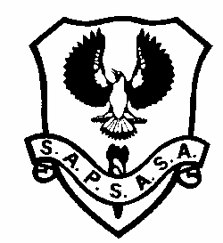
USE NETBALL CARNIVAL
Tuesday 9th May 2023
NARACOORTE NETBALL COURTS

- THUNDERBIRDS
- VIXENS
- FIREBIRDS
- SWIFTS
- LIGHTNING
- FEVER
- MAGPIES
- GIANTS

 | 10:00 | 10:30 | 11:00 | 11:30 | LUNCH BREAK | 12:30 | 1:00 | 1:30
Court 1 | 2 v 1 | 3 v 4 | 6 v 2 | 7 v 5 |  | 1 v 3 | 4 v 5 | 7 v 3
Court 2 | 3 v 8 | 1 v 7 | 7 v 8 | 8 v 4 |  | 4 v 2 | 8 v 1 | 8 v 2
Court 3 | 4 v 7 | 8 v 6 | 4 v 1 | 2 v 3 |  | 5 v 8 | 2 v 7 | 1 v 5
Court 4 | 5 v 6 | 2 v 5 | 5 v 3 | 6 v 1 |  | 6 v 7 | 3 v 6 | 6 v 4

- Teams should meet at the Naracoorte Town Courts at 9:45am
- Play will start at 10:00am sharp
- All players must bring their own water.
- All players must have a number clearly written on both arms (this is listed next to their name on the team sheet emailed to and handed out by the SAPSASA coordinators)
- Games will consist of 2 x 10 minute halves (3 min half time break)
- Games will be centrally timed – no injury stoppage
- Players are asked to bring their own lunch and drinks

