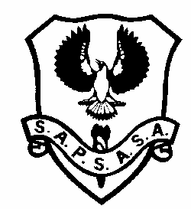
USE NETBALL CARNIVAL
Wednesday 28th April 2021
NARACOORTE TOWN COURTS
1 – FEVER | 2 – THUNDERBIRDS | 3 – VIXENS | 4 – LIGHTNING
5 – MAGPIES 6 – FIREBIRDS 7-SWIFTS 8-GIANTS 9-DIAMONDS

YEAR 6
YEAR 7

 | 10.00 | 10:55 | 11.50 | LUNCH BREAK | 1.00 | 1.55
Court 1 | 5 v 6 | 5 v 7 | 1 v 4 |  | Yr 6 (1st vs 2nd placing) | 6 v 7
Court 2 | 7 v 8 | 6 v 9 | 2 v 3 |  | Yr 6 (3rd vs 4th placing) | 8 v 9
Court 3 | 1 v 2 | 1 v 3 | 6 v 8 |  | 5 v 8
Court 4 | 3 v 4 | 2 v 4 | 5 v 9 |  | 7 v 9
 | 9-Bye | 8-Bye | 7-Bye |  | 6-Bye | 5-Bye

- Teams should meet at the Naracoorte Town Courts at 9:45am
- Play will start at 10:00am sharp
- All players must bring their own water. There is no sharing of food.
- All players must have a number clearly written on both arms (this is listed next to their name on the team sheet emailed to and handed out by the SAPSASA coordinators)
- All coaches need to have completed the COVID-19 online Infection Control Training
- Games will consist of 4 x 8 minute quarters (2 min first and third quarter break, 3 min half time break)
- Games will be centrally timed – no injury stoppage
- A barbecue and coffee van will be available – players are asked to bring their own lunch and drinks
- All attendees must practice appropriate social distancing

