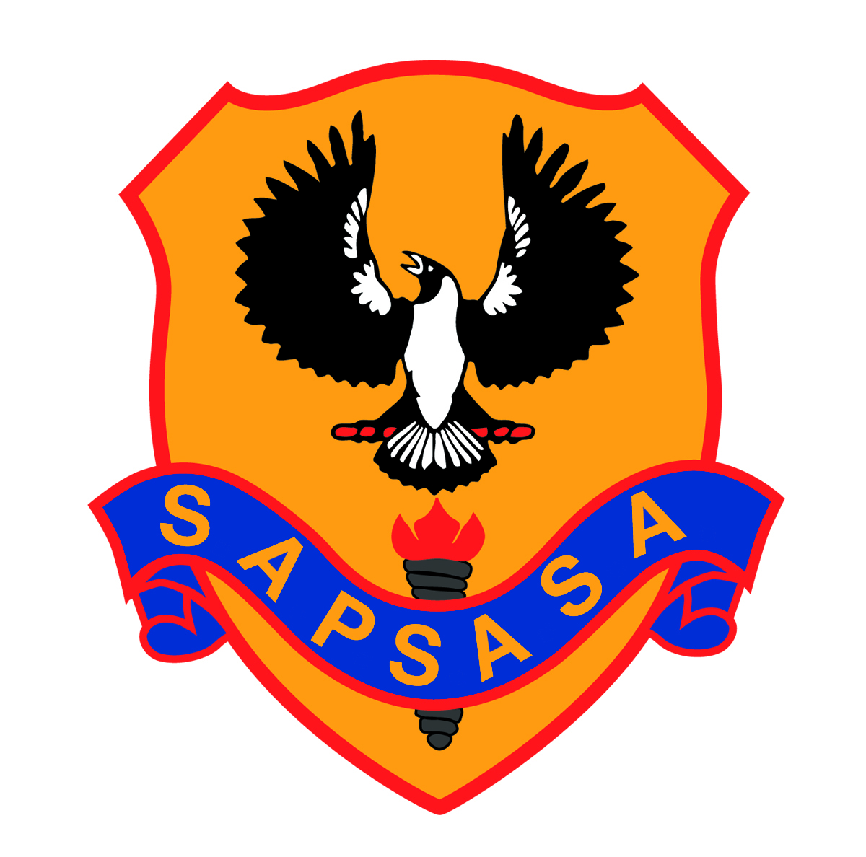
Convenor:
Carol Pfitzner
Mobile:
0429 863 707
Email:
carol.pfitzner242@schools.sa.edu.au
Est. 1912

Southern Country Zone Sapsasa Girls Cricket 2021
The Southern Country Zone would like to invite year 6 and 7 girls who are interested in playing Cricket against other Zones at the School Sport SA Zone Carnival to nominate to attend trials with the possibility of being selected in the Zone team.

How to nominate
THIS IS AN ESSENTIAL PROCESS – You must nominate on the following link: http://bit.ly/UpperSouthEastNominations2021
You will receive an email from SchoolSportSA, NoReply (School Sport Team). THIS IS THE CONSENT FORM for the trial and if selected, the state carnival - Please print, sign and return this form to your school by Thursday 18th September.

Carnival details
The carnival will be played in Adelaide during the school hours in the week of Monday 1st to Wednesday 4th November. The approximate cost of the carnival will be $116.00 (including team polo shirt and bucket hat) Transport to the carnival each day must be provided by parents. Josh Searle is the coach and has been appointed to supervise the team.

Trials
Two trials will be conducted and although it is not compulsory to attend both trials it would definitely help players development in the game of cricket.

The trial dates are as follows:

Wednesday 22nd September – 1.30pm – 4.00pm – Wortley Oval, Moore Street, Naracoorte

Wednesday 13th October – 1.30pm – 4.00pm, Virgo Park, Naracoorte Road, Bordertown

Could all students who are attending please email Josh Searle joshua.searle743@schools.sa.edu.au with your name, school and year level and which trial you will be attending.

Once a team has been selected, further details regarding the carnival and trainings will be provided to the student.

Further information
For more information, please ask your school Sapsasa representative or contact the convenor as per details above.

Coach: Josh Searle – Bordertown Primary School
Mobile: 0447 081 027
Joshua.Searle743@schools.sa.edu.au

