School Sport SA

Swimming Sapsasa State Championship

Updated 31 March 2022

2022 dates and venue
SA Aquatic and Leisure Centre
443 Morphett Road, Oaklands Park
Country division 1 and 2 and multiclass Friday 6 May
Metro division 1 and 2 Monday 9 May

Timing
8:30am Gates open (Division 1 arrive 8:30 – 9:00 / Division 2 arrive 9:00 – 9:30)
9.30am Division 1 warm up (20mins)
10.00am Division 2 warm up (20mins)
10.30am Marshalling 100m freestyle
10.40am Morning session starts (100m freestyle, butterfly, backstroke, 50m freestyle)
12.30pm approx Lunch
1.00pm (no earlier) Afternoon session starts (breaststroke, relays)
2.45pm approx Competition finishes

Metropolitan district divisions and colours
Division 1 |  | Division 2
Adelaide South East | Maroon, White | Adelaide North East | White, Navy, Red
Airport | Royal Blue, White | Barker | Blue, Green
City South | Red, Yellow | Hills | Gold, Black
East Adelaide | Double Blue | Onkaparinga North | Blue, Yellow
North Adelaide | Red, White | Onkaparinga South | Royal Blue, Gold
Port | Black, White | Para Districts | Yellow, Green
Southern Heights | Double Blue | Playford | Red, White, Royal Blue
South West | Red, Yellow, Blue | Salisbury East | Bottle Green, Yellow, White
Tea Tree Gully | Maroon, White | Southern Valley | Royal Blue, White
Torrens River | Red, Navy Blue | Western | Navy Blue, White

Country district divisions and colours
Division 1 |  | Division 2
Barossa and Light | Black, White | Central Eyre Peninsula | Brown, Gold
Gawler | Maroon, Gold, White | Kangaroo Island | Red, Black
Lower Eyre Peninsula | Black, White | Mid South East | Red, White, Blue, Black, Gold
Lower South East | Royal Blue, Gold | Murray Mallee | Red, Cornflower Blue, Yellow
Mid North | Double Blue, White | Northern | Navy, Yellow, Ochre, White
Murraylands | Navy, Red, Yellow | Northern Yorke Peninsula | Double Blue
North Eastern | Royal Blue, White | Pirie | Green, Gold
Riverland | Red, Black | Southern Yorke Peninsula | Gold, Royal Blue
Southern Fleurieu | Double Blue | Western Eyre Peninsula | Maroon, Yellow
Upper South East | Red, Navy, White | Whyalla | Red, White, Royal Blue

Officials acknowledgements
We are indebted to the officials of Swimming SA and volunteers who, year by year, support these championships so loyally. We are most grateful for the time and expertise, which they readily give to School Sport SA

Program of events
All events will be swum as timed finals.
Division 1 races will be swum first followed by division 2 races
Multiclass events only swum on country day.

Event number | Event age and description
Event 1 and 101 | Boys 10 to 12 year old 100m freestyle division 1 and 2
Event 2 and 102 | Girls 10 to 12 year old 100m freestyle division 1 and 2
Event 3 and 103 | Boys 10 year old 50m butterfly division 1 and 2
Event 4 and 104 | Girls 10 year old 50m butterfly division 1 and 2
Event 5 and 105 | Boys 11 year old 50m butterfly division 1 and 2
Event 6 and 106 | Girls 11 year old 50m butterfly division 1 and 2
Event 7 and 107 | Boys 12 year old 50m butterfly division 1 and 2
Event 8 and 108 | Girls 12 year old 50m butterfly division 1 and 2
Event 208 | Boys and girls 10 to 12 years multiclass students with disability 50m butterfly
Event 9 and 109 | Boys 10 year old 50m backstroke division 1 and 2
Event 10 and 110 | Girls 10 year old 50m backstroke division 1 and 2
Event 11 and 111 | Boys 11 year old 50m backstroke division 1 and 2
Event 12 and 112 | Girls 11 year old 50m backstroke division 1 and 2
Event 13 and 113 | Boys 12 year old 50m backstroke division 1 and 2
Event 14 and 114 | Girls 12 year old 50m backstroke division 1 and 2
Event 214 | Boys and girls 10 to 12 years multiclass students with disability 50m backstroke
Event 15 and 115 | Boys 10 year old 50m freestyle division 1 and 2
Event 16 and 116 | Girls 10 year old 50m freestyle division 1 and 2
Event 17 and 117 | Boys 11 year old 50m freestyle division 1 and 2
Event 18 and 118 | Girls 11 year old 50m freestyle division 1 and 2
Event 19 and 119 | Boys 12 year old 50m freestyle division 1 and 2
Event 20 and 120 | Girls 12 year old 50m freestyle division 1 and 2
Event 220 | Boys and girls 10 to 12 year old multiclass students with disability 50m freestyle
Event 21 and 121 | Boys 10 year old 50m breaststroke division 1 and 2
Event 22 and 122 | Girls 10 year old 50m breaststroke division 1 and 2
Event 23 and 123 | Boys 11 year old 50m breaststroke division 1 and 2
Event 24 and 124 | Girls 11 year old 50m breaststroke division 1 and 2
Event 25 and 125 | Boys 12 year old 50m breaststroke division 1 and 2
Event 26 and 126 | Girls 12 year old 50m breaststroke division 1 and 2
Event 226 | Boys and girls 10 to 12 year old multiclass students with disability 50m freestyle
Event 27 and 127 | Boys 10 year old 4x50m freestyle relay
Event 28 and 128 | Girls 10 year old 4x50m freestyle relay
Event 29 and 129 | Boys 11 year old 4x50m freestyle relay
Event 30 and 130 | Girls 11 year old 4x50m freestyle relay
Event 31 and 131 | Boys 12 year old 4x50m freestyle relay
Event 32 and 132 | Girls 12 year old 4x50m freestyle relay

Marshalling Flow Maps

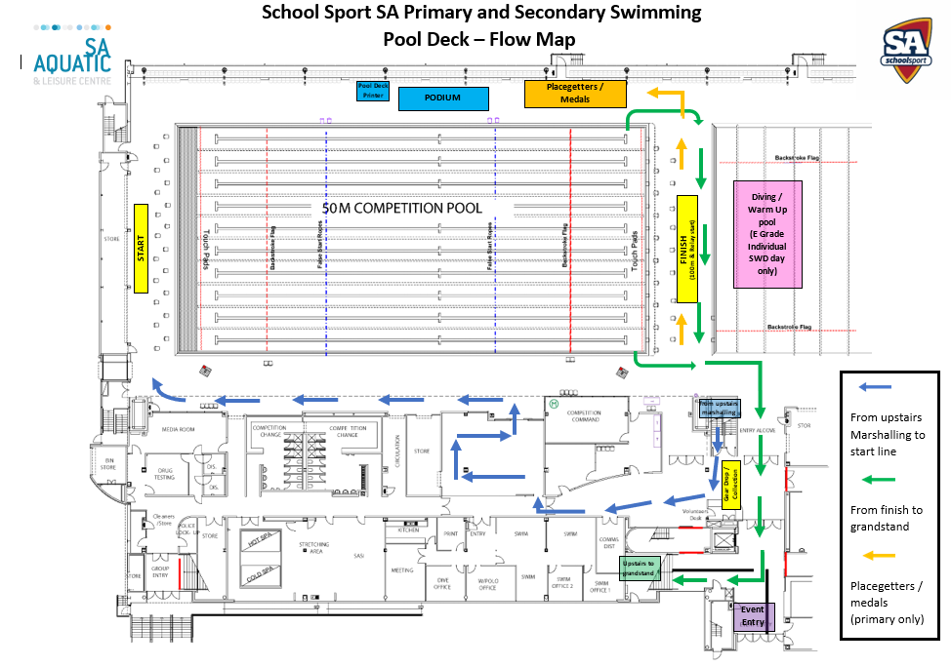
Pool Deck

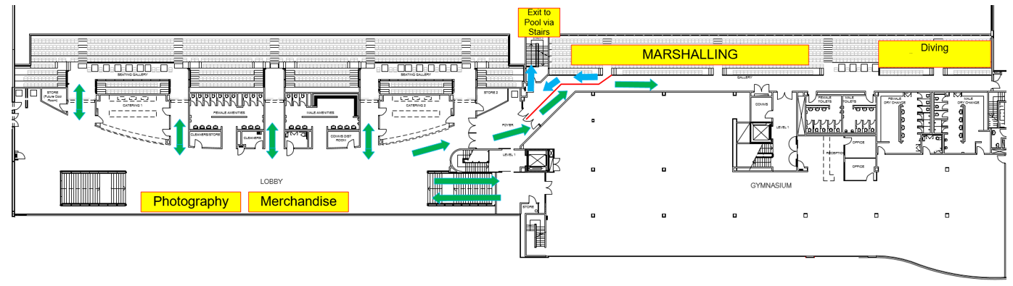
Grandstand Level -

Rules and conditions

13 year old participation
- 13 year olds in primary school can compete at the School Sport SA Sapsasa Swimming Championships.
- Swimmers will compete in the 12 year old age group
- 13 year old swimmers will receive points allocated for their finishing place and all swimmers finishing below will have their place upgraded by 1 and will be allocated points based on their upgraded finishing position.

Championship rules
Number of events
- 1 entry per event excluding wild card entries.
- Only 6 individual wildcards with a maximum of 2 competitors in any event.
- Swimmers can compete in no more than 3 individual events.
- Metropolitan district swimmers can compete in more than 1 relay if they have competed in less than 3 individual events.
- Country district swimmers can compete in 2 relays and 3 individual events.
Changes to events
- Must be submitted by the team manager at least 30 minutes prior to the first event of the session.
Event format
- School Sport SA reserves the right to divide any event into heats or to run concurrently any two or more heats.
- All individual and relay events are timed finals and placings will be determined on times.
Marshalling
- Swimmers must check into the marshalling area as soon as their event is called.
- Only swimmers and officials on duty can be in the marshalling area and pool enclosure.
The start
- Starting method will be 'take your marks', 'beep and light flash'.
- The 1 start rule applies.
- A false start will result in disqualification. Swimmers in individual events and relays will still be given the opportunity to swim if they have false started.
The finish
- Swimmers must remain in the pool in their lanes until told to leave the water.
- Some swimmers will be asked to wait on pool deck ready for medal presentations.
Points and awards
- Points are awarded for all events as
  - 1st place – 20 points
  - 2nd place – 18 points
  - 3rd place – 16 points
  - 4th place – 14 points
  - 5th place – 12 points
  - 6th place – 10 points
  - 7th place – 8 points
  - 8th place – 6 points
  - 9th place – 4 points
  - 10th place – 2 points
  - 11th place and higher – 1 point
- Medals will be award to first, second and third place getters in all events
- Competitors will receive a participation certificate
Protests
- A district team official must notify the event convenor of the intention to protest within 5 minutes of the event concluding. The Chief Referee will be advised and asked to provide a ruling. The Swimming SA referee's decision is final.
- Except where otherwise specified, the rules of Swimming SA will be used.
Relays
- Teams are made up of 4 swimmers from the same district (unless previously negotiated)
- Second, third and fourth swimmers must not dive into the water until the previous swimmer touches the wall.
Swimming costumes
- The costumes of all swimmers should be in good moral taste and suitable for the sport of swimming.
- Costumes must be non-transparent.
- Caps are optional.
- Swimmers who want their times used by Swimming SA the Swimming SA swimwear rule applies.
A summary of key points for swimming costumes are
- For males, the swimsuit shall not extend above the navel or below the knees.
- For females, the swimsuit shall not cover the neck or extend past the shoulders, nor shall extend below the knees. The upper back shall be bare. The swimsuit may be 1 or 2 pieces.
- No zippers or other fastening system is allowed, except for a tie around the waist.
- Only 1 swimsuit is permitted. Swimmers may choose to wear underwear as long as it is not exposed.
- The swimsuit must be made of woven material and not have any plastic or polyurethane panels.
- Must be FINA approved or a traditional swimsuit commercially available.

Records 50m pool
Boys Girls
Freestyle 10 year 50 Metres
J. Bastian (Southern Heights) 2011 32.21s S Song (Adelaide South East) 2007 32.88s
Freestyle 11 Year 50 Metres
J. Bastian (Southern Heights) 2012 29.80s E. Philp (South West) 1990 30.49s
Freestyle 12 Year 50 Metres
J. Bastian (Southern Heights) 2013 28.44s T. Bastian (Southern Heights) 2012 29.19s
Freestyle 10 to 12 years 100 Meters
No record No record
Breaststroke 10 Year 50 Metres
T. Hore (Tea Tree Gully) 1996 43.06s A. Margrison. (Salisbury East) 1997 44.32s
Breaststroke 11 Year 50 Metres
B. Brewerton (East Adel) 2004 40.30s K. George (Port) 1998 40.34s
Breaststroke 12 Year 50 Metres
T. Hore (Tea Tree Gully) 1998 37.68s E. Thorn (Barossa & Light) 2005 35.72s
Backstroke 10 Year 50 Metres
S. Beinke (Airport/ Western) 1995 37.12s S Song (Adelaide South East) 2007 38.00s
Backstroke 11 Year 50 Metres
J. Bastian (Southern Heights) 2012 35.97s M. Maselli-Sheridan (Adel Sth East) 2006 35.21s
Backstroke 12 Year 50 Metres
J. Thomas (Onkaparinga North) 2014 32.93s S. Hancl (East Adelaide) 2018 34.02s
Butterfly 10 Year 50 Metres
B. Hammond (Lower Eyre Peninsula) 2017 34.82s S Song (Adelaide South East) 2007 35.55s
Butterfly 11 Year 50 Metres
B. Hammond (Lower Eyre Peninsula) 2018 32.57s E. Siddle (Tea Tree Gully) 2012 33.48s
Butterfly 12 Year 50 Metres
J. Bastian (Southern Heights) 2013 31.23s M Maselli-Sheridan (Adel Sth East) 2007 30.02s
10 Year Freestyle Relay
Airport Western 1995 2:24.91m Airport/Western 1993 2:29.37m
11 Year Freestyle Relay
East Adelaide 2018 2:18.35m East Adelaide 2017 2:17.23m
12 Year Freestyle Relay
East Adelaide 2019 2:07.53m East Adelaide 2018 2:06.23m
Events no longer swum
Freestyle 13 Year 50 Metres
K. Chalmers (Lower Eyre Peninsula) 2011 27.47s T. Bastian (Southern Heights) 2013 27.79s
Freestyle Open 100 Metres
K. Chalmers (Lower Eyre Peninsula) 2011 57.78s M Maselli-Sheridan (Adel Sth East)2007 1.00.40m
13 Year Freestyle Relay
East Adelaide 2019 2:03.17m Airport 2013 2:06.68m
Breaststroke 13 Year 50 Metres
Z. Phua (East Adelaide) 2018 35.08s E Mcgiffert (Gawler) 2014 36.14s
Backstroke 13 Year 50 Metres
J. Desmond (Playford-Elizabeth) 2012 32.79s S. Healy (Torrens River) 2017 31.96s
Butterfly 13 Year 50 Metres
K. Chalmers (Lower Eyre Peninsula) 2011 29.01s E. White (East Adelaide) 2016 29.80s
Open Medley Relay 4x50 Metres
Southern Heights 2017 2:17.61m East Adelaide 2016 2:16.97m

Previous Championship Winners
State Metropolitan Country
1954 Renmark Grange Strathalbyn
1955 Strathalbyn Grange Strathalbyn
1956 Strathalbyn Grange Strathalbyn
1957 Grange Grange Renmark
1958 Renmark Grange Renmark
1959 Renmark Grange Renmark
1960 Renmark Grange Renmark
1961 Renmark Henley Renmark
1962 Renmark Grange Renmark
1963 Berri Grange Berri
1964 Berri Largs Bay Berri
1965 Berri Burnside Berri
1966 Berri Seaton Park Berri
1967 Berri Burnside Berri
1968 Loxton Linden Park Loxton
1969 Elizabeth Downs Elizabeth Downs Loxton
1970 Loxton Linden Park Loxton
1971 Para Hills Para Hills Loxton
1972 Para Hills Para Hills Berri
1973 Para Hills Para Hills Renmark
1974 Para Hills Para Hills
1975 Linden Park Linden Park Renmark
1976 Largs Bay Largs Bay Berri
1977 Burnside Burnside Bordertown
1978 Largs Bay Largs Bay Renmark
1979 Largs Bay Largs Bay Bordertown
1980 Largs Bay Largs Bay Berri
1981 Blackwood Blackwood Berri
1982 Blackwood Blackwood Berri
1983 Elizabeth South Elizabeth South Lower South East
1984 Torrens River Torrens River Lower South East
1985 South East South East Riverland
1986 Port Port Riverland
1987 Western Western Gawler
1988 Western Western Lower South East
1989 N/A South East Riverland
1990 N/A South East Riverland
1991 N/A South East Riverland
1992 N/A South East Lower Eyre Peninsula
1993 N/A South East Riverland
1994 N/A Airport/Western Riverland
1995 N/A Airport/Western Riverland
1996 N/A Tea Tree Gully Riverland
1997 N/A Southern Valley Southern
1998 N/A Tea Tree Gully Riverland
1999 N/A Port Hills
2000 East Adelaide Riverland
2001 East Adelaide/Port Riverland
2002 East Adelaide Riverland
2003 East Adelaide Gawler
2004 East Adelaide Riverland

Previous Championship Winners cont
State Metropolitan Country
2005 South East Riverland
2006 Adelaide South East Riverland
2007 Adelaide South East Riverland
2008 East Adelaide Gawler
2009 South West Southern
2010 East Adelaide Lower Eyre Peninsula
2011 South West Gawler
2012 East Adelaide Gawler
2013 East Adelaide Hills
2014 East Adelaide Hills
2015 South West Lower Eyre Peninsula
2016 East Adelaide Lower Eyre Peninsula
2017 East Adelaide Hills
2018 East Adelaide Mid North
2019 East Adelaide Lower Eyre Peninsula
2020 No competition held due to COVID-19
2021 Division 1 East Adelaide Gawler
2021 Division 2 Tea Tree Gully Murraylands

